SECURE EMAIL SYSTEM
DACS3101 – Applied Cryptography

60301911 - Marium Ahmed
60102445 - Hamra Nadeem
60105648 - Awwab Khalil
60104487 - Suhail Omar

Dr. Abdullatif Shikfa
November 22nd, 2025

Table of Contents
Introduction 3
System Overview 3
Client Application (GUI) 3
Server Application (Flask Backend) 4
Cryptographic Module 4
High-Level Workflow: 6
Phase-by-Phase Solution Description 7
Phase 1: Symmetric Encryption Implementation (AES) 7
Strengths: 8
Phase 2: Basic Client–Server Communication & Local Storage 8
Server-side: 8
Client-side: 11
Phase 3: Cryptographic Design 12
Hybrid Cryptosystem: 12
Sending process: 12
Receiving Process: 13
Phase 4: Implement Asymmetric Cryptography (RSA) 13
Authentication: 15
Phase 5: Integrity Verification and Secure Inbox 16
Phase 6: System Integration, Security Testing, and Documentation 17
Crypto module-Client Integration: 18
Local Storage: 18
GUI integration: 18
System Functionality: 18
Phase 7 (Bonus): User Interface / Quality of Experience 21
Design Approach: 21
Functionalities mapped to code: 22
Detailed User Manual 24
System Requirements: 24
Running the System: 25
Start Server: 25
Start Client: 25
Registration: 26
Logging In: 29
Email Sending Process: 31
Viewing Inbox: 35
Logging out: 36
Teamwork Distribution 37
Awwab Khalil: Client Application and Graphical User Interface 37
Marium Ahmad: Server Development 38
Suhail Omar: Cryptography Implementation 38
Hamra Malik: Documentation, Testing and Presentation 38
Conclusion 38

Introduction
Message sharing and online communication has become a very frequent exchange in the modern time. Messages sent over the internet are prone to many sort of attacks and privacy violations if the communication is not secured properly. Hackers or people with malicious intent could intercept the communication and alter it for their own benefits. Such risks could include identity impersonation, information leakage, and manipulation of communication.
Keeping such risk factors in mind, we studied different cryptographic algorithms and techniques on how to make this mode of communication as secure as possible. We implemented a Secure Email System that protects user’s messages as they travel over the network. In this report, we will go into detail about how we achieved this. The key idea was that only the intended recipient should be able to read the message, the receiver can verify the sender’s identity, and any alteration or tinkering with the message that is not intended by either parties can be detected.
Among the cryptographic techniques that we used, we combined RSA public-key cryptography, AES symmetric-key encryption, digital signatures, and hashing (SHA-256) to guarantee the CIA triad. The encrypting and decrypting of the messages takes place completely on the client side. This was to make sure that the server never sees the plaintext data.
After implementing these techniques, in order to guarantee a comfortable user interaction, we implemented a graphical user interface (GUI) that allows a user to register, login, send messages and view their inbox. The server is implemented using Flask and the storage is only for the cipher-text, it cannot decrypt or change the content of the messages.
In this report, we will go over the system in detail, propose a phase-by-phase solution, cryptographic methods we used, a user manual, our teamwork distribution and the challenges that we faced throughout this entire process.

System Overview
In our secure email system, we have split the client part, server part, the cryptographic operations and the message storage. There are three basic components:

Client Application (GUI)
- Built using Tkinter
- The interface for user registration, login, sending messages, and viewing inbox
- Handles encryption and decryption of incoming and outgoing messages
- Generates RSA keys and stores them along with user data

Server Application (Flask Backend)
- Runs on http://127.0.0.1:5000/
- Stores a list of registered users as well as their respective public keys
- Stores encrypted messages of each user in a user inbox
- There is no decrypting on this end
- Gives API endpoints:
  - /register
  - /pubkey/<username>
  - /send
  - /inbox/<username>

Cryptographic Module
- The crypto mind behind the entire secure communication
- Handles RSA key pair generation
- AES encryption and decryption
- RSA encryption and decryption for symmetric keys
- SHA-256 hashing
- Digital signature and verification

High-Level Workflow:
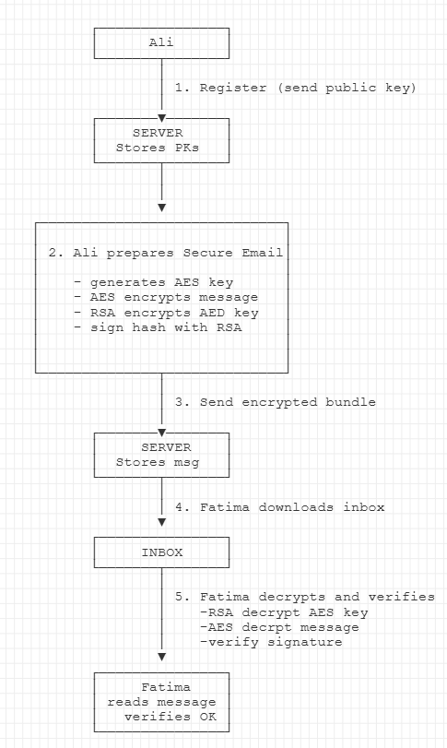
Created using asciiflow

Phase-by-Phase Solution Description

Phase 1: Symmetric Encryption Implementation (AES)
We chose AES (Advanced Encryption Standard) in 256-bit mode, a commonly used standard for protecting data during transmission and in storage. It is considered most secure as of now with our current technology and provides security against brute force attacks. For our design, AES handles encrypting the actual message content, this guarantees confidentiality in our secure email system.
Since it is a symmetric algorithm, one secret key is used for encrypting and decrypting. Since we are encrypting the body of an email, AES is the better option as it is faster than RSA in encrypting longer messages. RSA is used later in our system for the AES key.
All our AES logic is stored in the full_encryption.py file. The three main functions are:
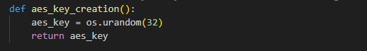
This function generates a 256-bit AES key, the “os.urandom(32)” generates a cryptographically secure random number (32 bytes) using the OS of the system. This function is used to generate a key each time a message is sent, and each session has a new key generated.
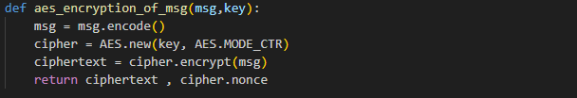
This function does the actual encryption of the body of the message in the email. First it converts the message to bytes using “msg.encode()”. AES is used in CTR mode, which is a safer option for variable length-messages. The plaintext is encrypted to produce ciphertext. In our encryption, we have used nonce (similar to initialization vector) that will be later used for the decryption.
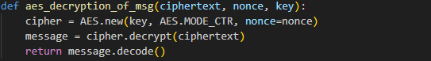
This function handles the decryption using the nonce and the key previously saved as list of integers. Any alteration in the key or the nonce will not give us back the plaintext, so this can help us detect problems.

Strengths:
The ciphertext and nonce are not hidden on the network, but anyone who intercepts the conversation cannot recover the plaintext without knowing the corresponding AES private key. This keeps the communication secure between both the parties.
A new key is generated per session, this assures that even if one key is compromised, it does not affect the entire system.
Our AES keys are generated using the OS’s CSPRNG, which is more secure for cryptography.
This encryption and decryption is done entirely on the client side. The server NEVER sees the plaintext or the AES key.

Phase 2: Basic Client–Server Communication & Local Storage
In phase 2, we had to incorporate our cryptography logic into a real client-server system. Rather than storing messages locally, we worked on an interactive server that allows users to register and store their encrypted emails, a client that can talk to the server, and local storage (lists and json) on the client side for the user accounts and keys.
This phase focused on the interface, and data storage.

Server-side:
The server.py file implements the server using the Flask framework. It’s a very simple email provider. It keeps two main data structures in `data.json` file:
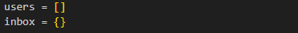
Users: a list of dictionaries with “username” and “pubkey”
Inbox: a dictionary that maps username to a list of message objects
The following code handles saving & retrieving data from `data.json` file. It also uses `Lock` to make sure to two requests modify `data.json` file at the same time. This is to prevent data corruption in production scenarios.
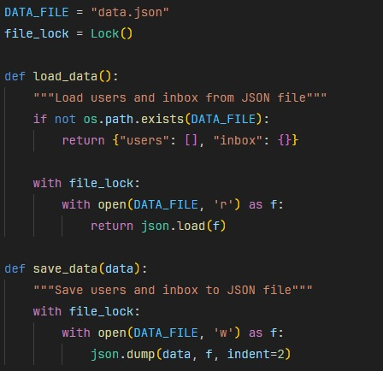

Server provides 4 main endpoints:
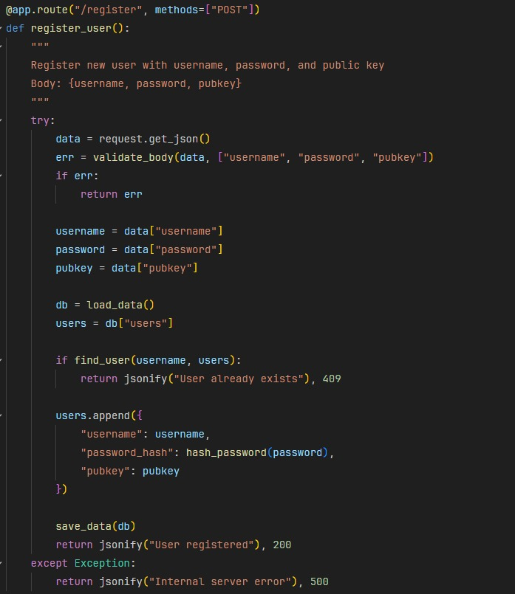
This is for user registration to the platform. The server does multiple checks: all required fields present, username already registered or used before. Once a user is registered, the user’s information is appended to the “users” list and creates an empty inbox for them to later store their messages. This endpoint is called by the client upon registration of a new user. The public key is then sent to the server, the private key, however, never leaves the client
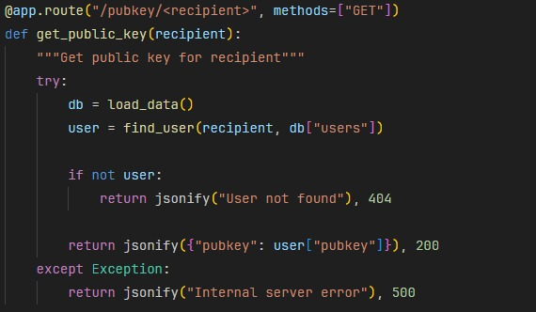
This route searches the username in the list of users and returns their public stored key. This endpoint is used by the client before a message is sent to recover the public key and encrypt their AES session key.
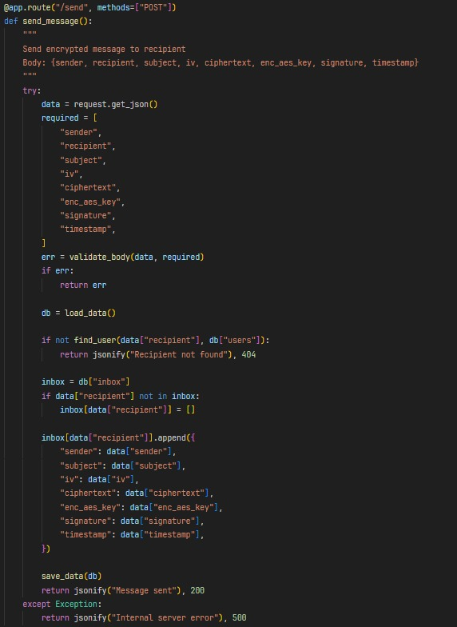
This route first validates if all the required fields exit. Once verified it stores the message object to the recipient’s inbox. Our main focus here was that the server is not doing any of the decrypting or inspecting of the message, it only stores whatever encrypted bundle it receives.
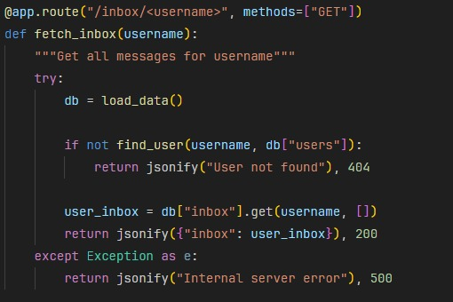
This route is just used to allow the user to view their inbox. Upon user’s request to view inbox, the client calls this endpoint and then the decryption and verifying of the messages is done locally.

Client-side:
The client.py file runs the client code. We have used the requests library to talk to the Flask server. The base URL is “SERVER_URL = http://127.0.0.1:5000
Helper functions are used by the GUI logic so the code remains clean and focused on the interaction instead of HTTP details like api_register(username,pubkey), api_get_pubkey(username), api_send(message_packet) and api_inbox(username)
Local storage on the client is done on the users.json file.
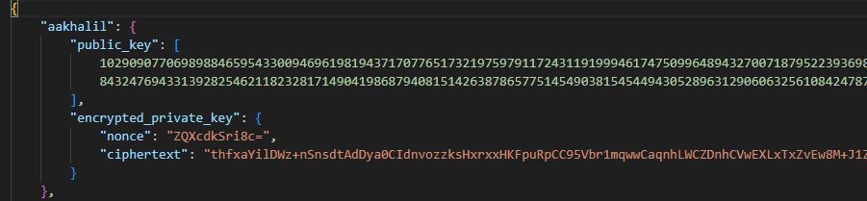
The structure of the storage is as shown above. The main idea is that when user registers, the client generates an RSA key pair. The private key is encrypted using a password derived AES key (this way the private key remains unknown). The public key and encrypted private key are saved respectively. Only the public key is sent to the server.
Upon logging in, the client reads this users.json file. It searches up the username, decrypts the stored private key using user’s password. If decryption is successful, the client holds the RSA private key in memory for that session.
The point of security is that the server never sees or stores the private keys. Private keys are stored on the client side and are password-protected. This design also allows the storage of multiple accounts.

Phase 3: Cryptographic Design
Our crypto implementation ensures we have a hybrid cryptosystem that provides:
- Confidentiality: No one except the intended party can read the message
- Integrity: Any modifications to the message can be detected
- Authentication: Identity of sender can be confirmed via signatures.

Hybrid Cryptosystem:
In our design, we combined the use of AES and RSA. Each algorithm is used for a specific task as follows:
- AES-256, which is a symmetric algorithm, is used to encrypt the body of the message.
- RSA, which is asymmetric, is used to encrypt only the AES key.
- Combination of SHA-256 and RSA is used for digital signatures to guarantee integrity.
Every secure email has these characteristics: ciphertext (AES-encrypted), nonce, encrypted AES key(done using recipient’s public key), signature (computed with hashing plaintext and sender’s private key) and metadata.
To have a cryptographic view of how the sending and receiving process works, the steps are mentioned as follows along with a flow diagram for simplicity:
Ali sends a message to Fatima, here is how the transmission works behind the scenes:

Sending process:
- Fatima’s public key is fetched by client using /pubkey/Fatima, thus Fatima’s public key is received (n, e)
- A fresh AES session key is generated with aes_key = aes_key_creation()
- The plaintext message typed out by Ali is encrypted with AES using ciphertext, nonce = aes_encryption_of_msg(plaintext, aes_key)
- The AES key is encrypted using Fatima’s public RSA key using enc_aes_key = rsa_encryption(aes_key, fatima_public_key)
- The digital signature is created in 2 steps: a digest is generated of the plaintext using SHA-256 with digest = hash_string_sha256(plaintext), then the digest is signed with Ali’s private key using signature = rsa_encryption(digest, ali_private_key). This guarantees authentication.
- A JSON object is constructed using all the generated parameters and then the message packet is sent to the server. There is no decryption done by the server, it directly appends the packet to the recipient’s inbox
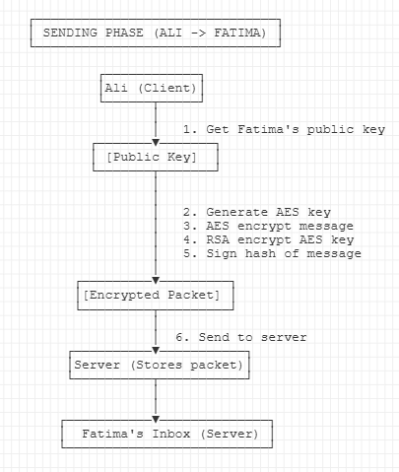
Created using asci flow

Receiving Process:
As Fatima opens her inbox to check the sent message, this is what the backend does:
- The encrypted messages are downloaded by client using /inbox/Fatima and the list of the encrypted message packet.
- The AES key is recovered using the RSA with aes_key = rsa_aes_decrypt(enc_aes_key, fatima_private_key)
- The message is decrypted by converting the stores ciphertext and nonce lists back into bytes with plaintext = aes_decryption_of_msg(ciphertext, nonce, aes_key)
- Verification of the digital signature is done by recomputing the hash of the derived plaintext using digest1 = hash_string_sha256(plaintext), the signature is decrypted using Ali’s public key with digest2 = rsa_str_decrypt(signature, alice_public_key). The two digests are compared. If they are the same then we know for sure the message has not been modified, this guarantees integrity.
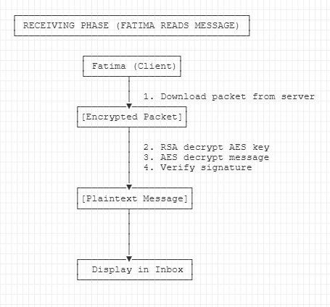
Created using ascii flow

Phase 4: Implement Asymmetric Cryptography (RSA)
We implemented RSA encryption and decryption for key exchanging and digital signatures. Unlike AES which was used to encryp the body of the email, RSA is slower and thus used as such. We created RSA key pairs, used them for encrypting and decrypting, and combined RSA with AES for hybrid encryption.

The Math of RSA:
RSA involves generation of 2 large prime numbers p and q. The product of these two numbers guarantees the security of our RSA.
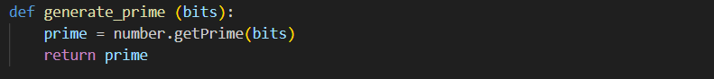
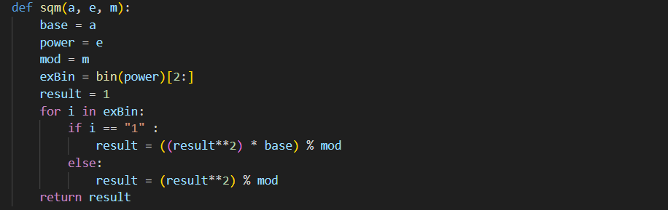
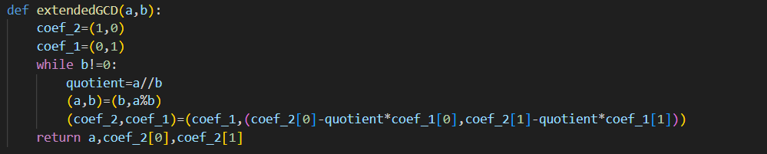
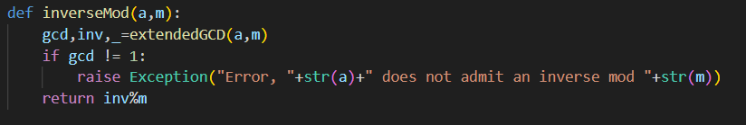
These functions are responsible for carrying out the math aspect of RSA.
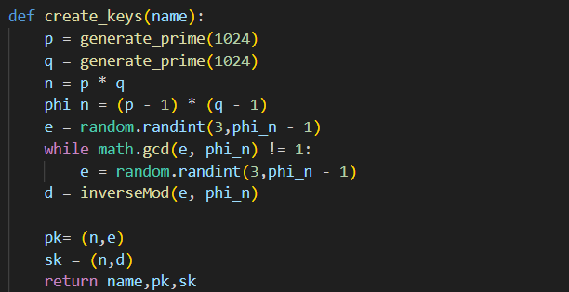
This function is used to generate the public and private key pairs that will be later used for encryption and decryption respectively. The public key is sent to the server during registration. The private key is never shared, it is further encrypted and stored locally.

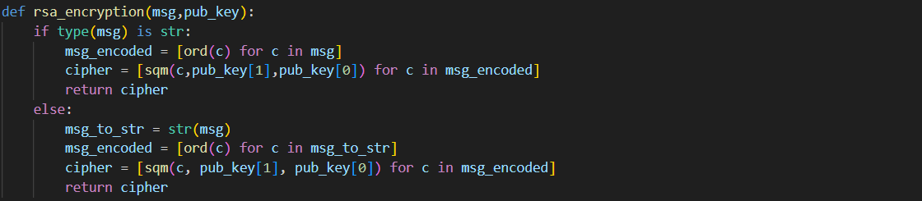
This function is used for encrypting the AES session key with the digest of the message. The sqm() function is used for the modular exponentiation.
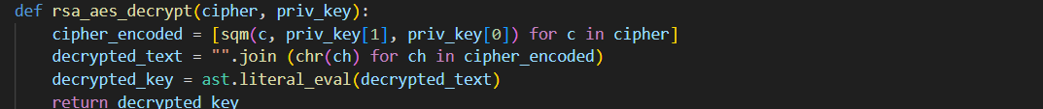
This recovers the AES session key on the recipient’s side using their private key.
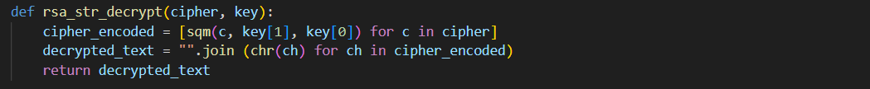
This function decrypts the session key after the message has been decrypted. It is responsible for decrypting the ciphertext back to the plaintext.

Authentication:
We also implemented RSA for user authentication. This was to ensure that the receiver knows the identity of the sender of the message and that it is not a malicious party. This was done by creating digital signatures which ensure message integrity as well as authentication. The message is hashed using SHA-256 and then signed using the sender’s private key, which is then verified on the receiver’s side using sender’s public key.
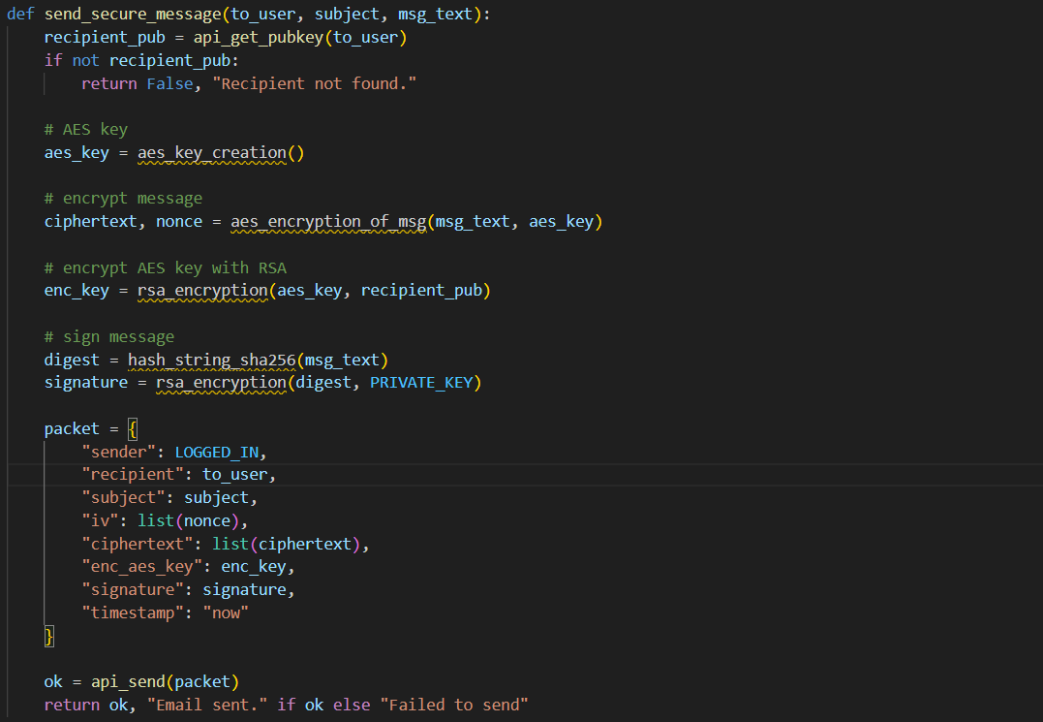
The send_secure_message function first hashes the message and then encrypts the digest with the private key of the sender. This is then verified on the receiver’s side using the public key of sender.

Phase 5: Integrity Verification and Secure Inbox
To guarantee secure communication, we also needed to ensure that the message is not altered during transmission. To align with integrity, the message verification flow is as follows:
- The message, AES key and signature (encrypted) are retrieved from the server’s inbox endpoint.
- The receiver uses their private RSA key to decrypt the AES session key with rsa_aes_decrypt()
- The message is decrypted using the AES key
- The new decrypted message is hashed and the digest is compared with the received signature (which contains the previously computed digest)
- The function below carries this out
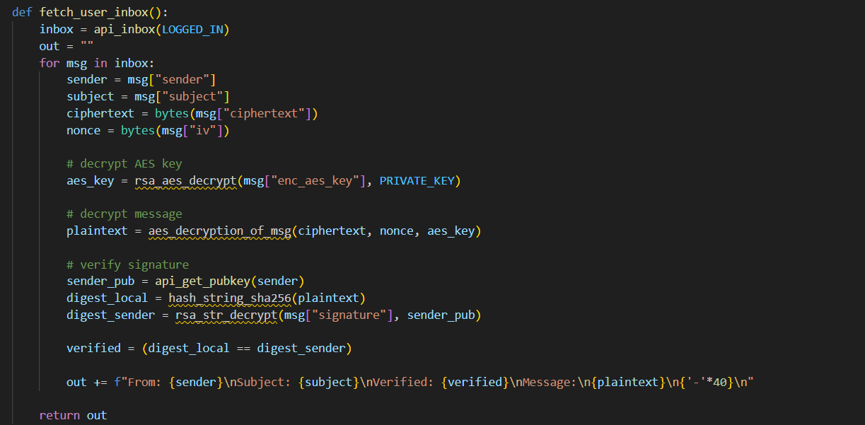

The inbox stores messages in an encrypted form. Once the user requests to view their inbox, the decryption process is in this order: AES key, message decryption and then finally displaying the message in the inbox upon verification.
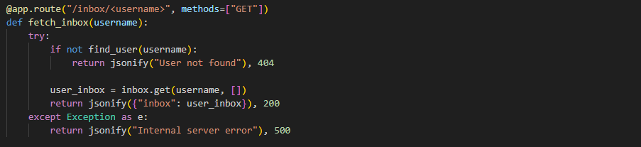
The messages are stored in a dictionary on the server side. The above route allows the user to view their inbox securely and retrieve contained messages.

Phase 6: System Integration, Security Testing, and Documentation
We had all the cryptography pieces, the client side set up, the server side functional, next step was to ensure they flow with each other smoothly and actually guarantee that we are achieving what we hoped to achieve. Here’s how we made our different parts of the machine work together as a whole:

Client-Server Integration:
The client uses HTTP requests to interact with the Flash server on http://127.0.0.0:5000
The client has multiple endpoints to directly interact with the server. Calls like /register, /pubkey/<username>, /send, /inbox/<username>. The server stores the encrypted messages and public keys.

Crypto Module-Client Integration:
The client uses functions from the full_encryption.py file to carry out the cryptography aspect. It calls on functions to generate RSA key pairs, generate session AES keys, encrypting and decrypting with AES, computing digests, creation and verification of digital signatures. All of this happens in between user interaction (user clicking ‘send’) and when they view their inbox.

Local Storage:
We opted for creating a local storage for our system. When a user registers, new RSA key pair is generated, private key is encrypted and stored with the public key. When a user logs in, the client interacts with this local storage to find the entry of the username and proceeds to decrypt the stored private key using user entered password.

GUI integration:
We created a simple interface to make user interaction easier and simpler. The system follows simplicity because the majority of the work is in the backend. We will discuss more in detail about the implementation of this GUI in the next phase.

System Functionality:
This project focuses on security. We tested our system’s functionality to ensure it works properly and gives the security that we intend for it to have. We carried out tests to check functionality. Here’s what testing looked like for us:

Registration flow:
- Start the server
- Register with a new user and password
- Confirm public key shows on the server
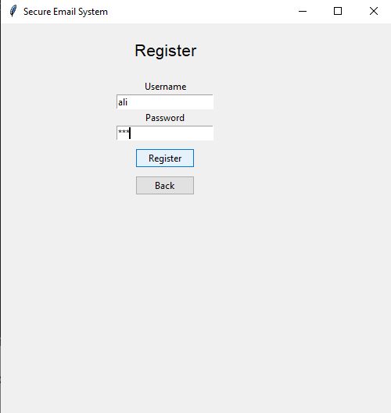
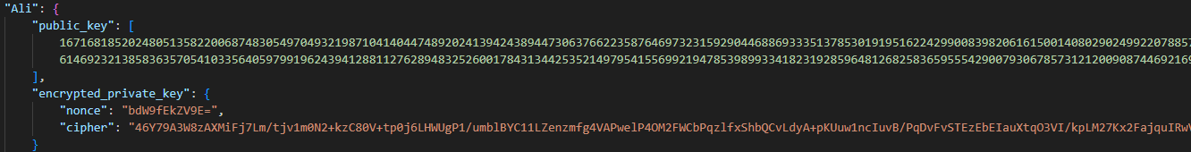
The user’s entry is created in the users.json file with the encrypted private key.

Login Flow:
- When user logs in with correct username and password, they are given access
- If password is wrong, the access is denied (private key decryption fails)
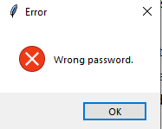

Message-sending Flow:
- We registered at least two users to start communication between them
- Ali writes a message to Fatima and sends it
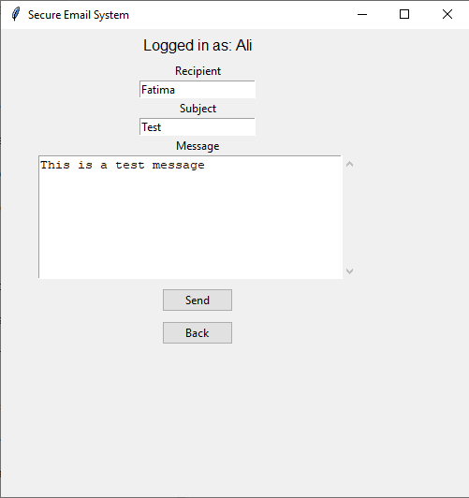
- In the backend, the client fetches Fatima’s public key from the server
- A new AES key was generated
- The message and AES key were encrypted and sent to /send
- Server stores a new message in Fatima’s inbox
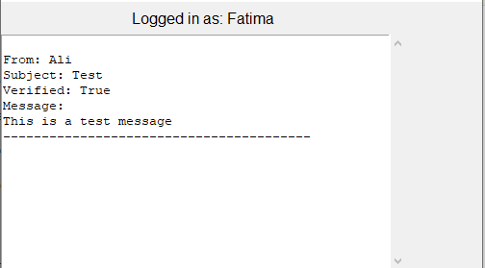

For documentation, we have created data flow designs to visualize the flow of communication between two users. We constructed a detailed user manual (which will be attached below) for ease of user. We also worked on a detailed report highlighting all the major and minor aspects of this project, what thinking went into applying the certain cryptographic algorithms, and how we focused on perfecting the flow of secure communication.

Phase 7 (Bonus): User Interface / Quality of Experience
The objective here was to implement a simple user-friendly interface so even people with no technical knowledge could interact with our system with ease and surety that their communication will be secure. It is the main point of interaction between the user and the backend where all the cryptographic interactions that we have discussed earlier take place.
It was optional to implement but we wanted to make our system more intuitive and easier to demonstrate, and as close to a real-world secure communication application as we could.

Design Approach:
The GUI was built using Tkinter which is a Python built-in library. The GUI contains “screens” that were later linked together.
- Main menu
- Registration Window
- Login Window
- Dashboard Menu
- Send Email Window
- Inbox Window
Each window has a corresponding function in the client code

Functionalities mapped to code:

Registration Interface:
When user registers and the ‘Register’ button is clicked, the crypto logic is executed behind the scenes, and a status on the screen indicated success or error.
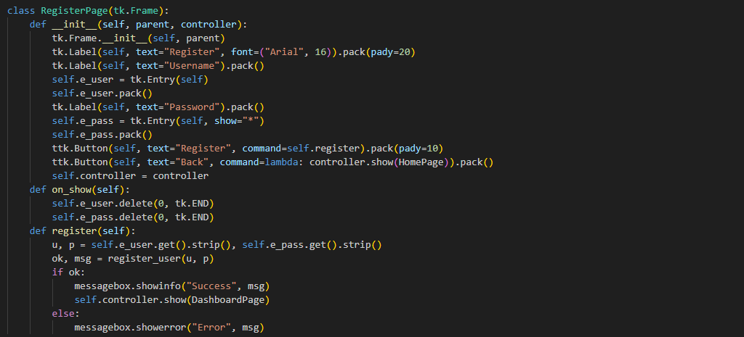

Login Interface:
When user logs in with the previously registered credentials and the ‘Login’ button is clicked, the users.json is loaded and username is checked. Successful attempt shows success message and if not, error is shown.
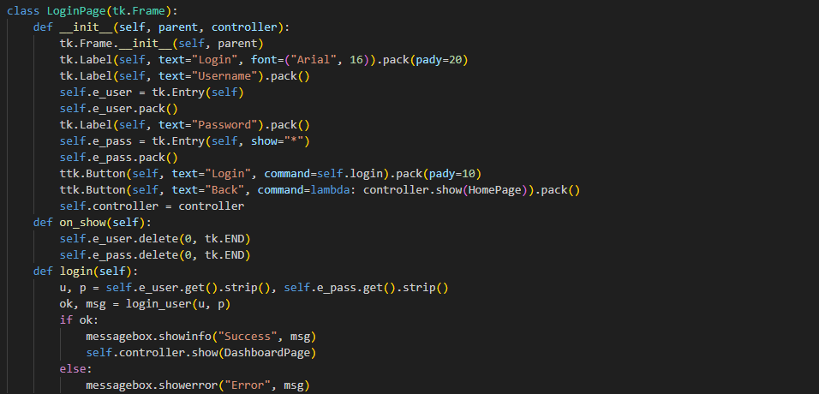

Main Dashboard:
Upon logging in, the user has three options: Send Email, View Inbox, Logout. These directly correspond to functions in the client code.
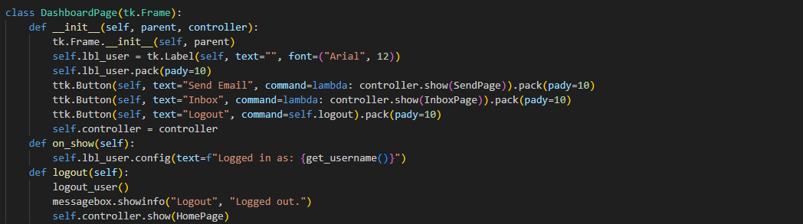

Send Email Window:
The is where all the encryption happens behind the scenes. The user inputs the recipient’s username, Subject and constructs the body of the message. Upon clicking ‘Send’, all the crypto logic takes place. The GUI then displays ‘Email sent’ or ‘Failed’ as per status. The behind the scenes is never shown to the user.
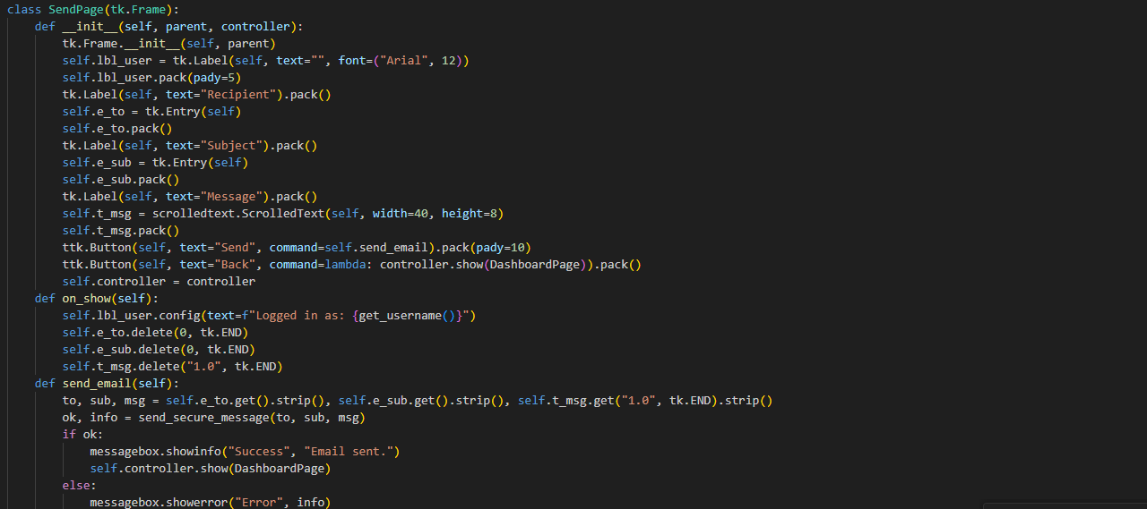

Inbox Window:
When user opens inbox, the GUI displays the email in a readable format with a ‘verification’ tag as well.
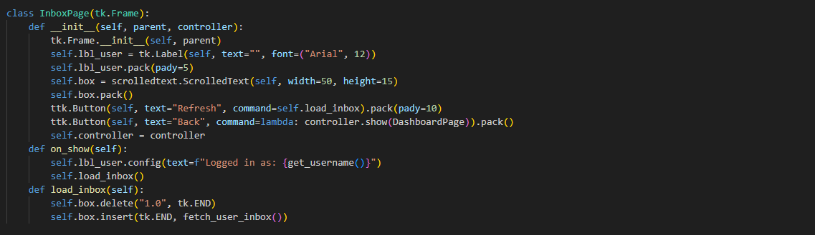

Detailed User Manual
This user manual will go into detail about how to install, run, and use the Secure Email System. We will cover all aspects from registration, login, sending emails, and viewing inbox messages.

System Requirements:
To run the system, you must have Python 3.x version installed. The required libraries are:
- Flask
- Requests
- Pycryptodome
- Tkinter (included with python)
You may carry out the following commands to run these:
pip install flask
pip install requests
pip install pycryptodome

Running the System:

Start Server:
Inside the folder containing your files, run the following command:
python server.py
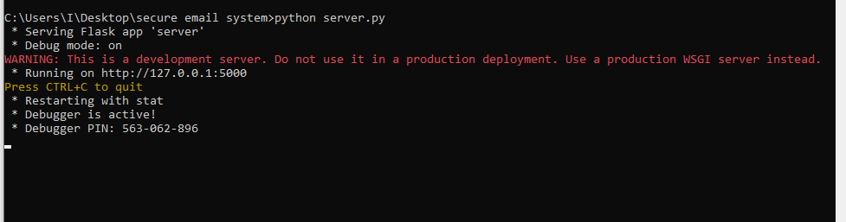
You should see the above screen in the Terminal Window

Start Client:
In the client folder, we run the following command on cmd:
python client.py
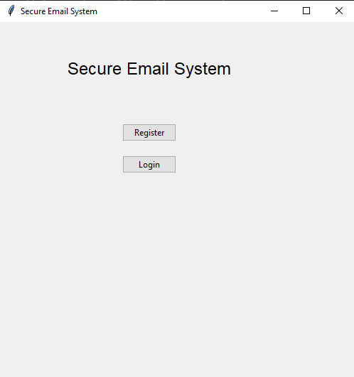
You should see the above window as soon as you run the client.

Registration:
Click on ‘Register’
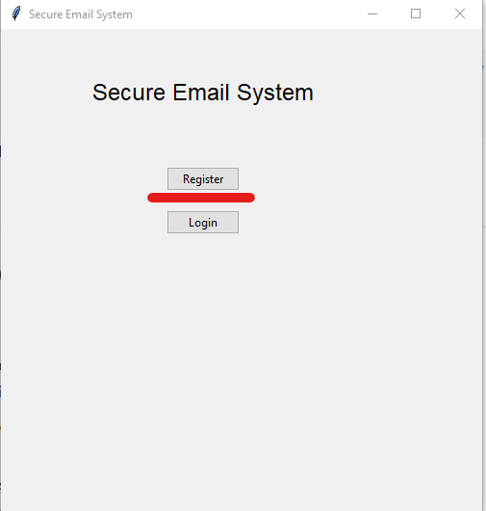
You will see the following page:
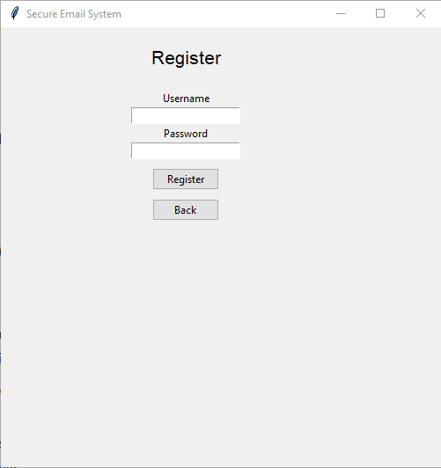
Enter a username and password, and then click register.
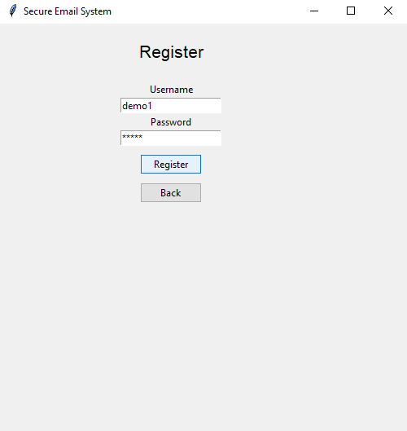
You will see a pop up indicating successful registration
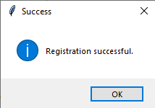

Logging In:
You will automatically be guided to the login page upon registration, but if you wish to login from the main page, then select Login
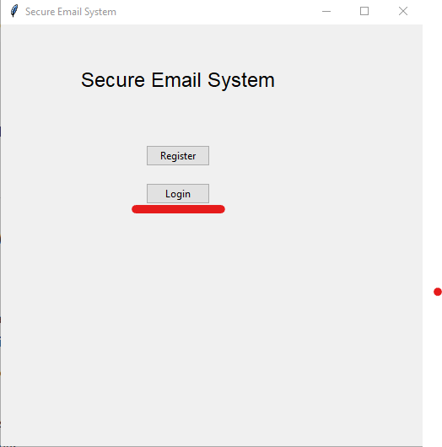
Upon entering credentials and clicking ‘Login’ you will see a popup indication success
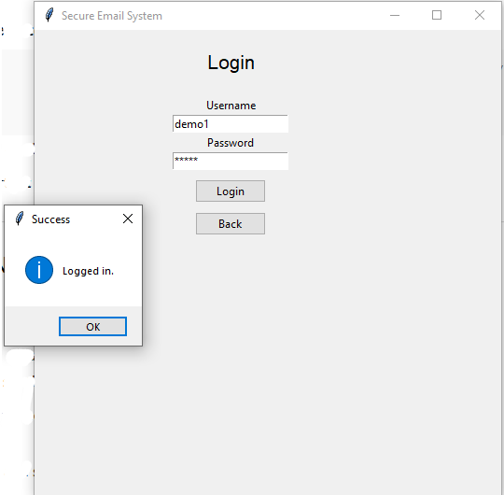

Email Sending Process:
You will be taken to a Dashboard that appears as so:
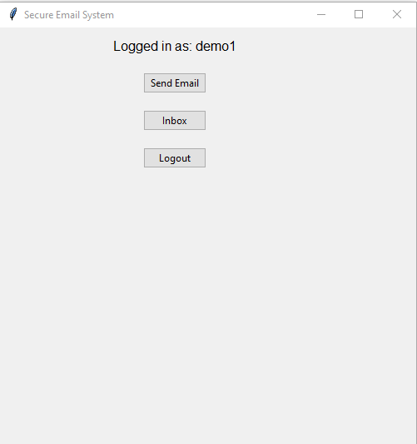
Select ‘Send Email’ to send an email. It will take you to the following page.
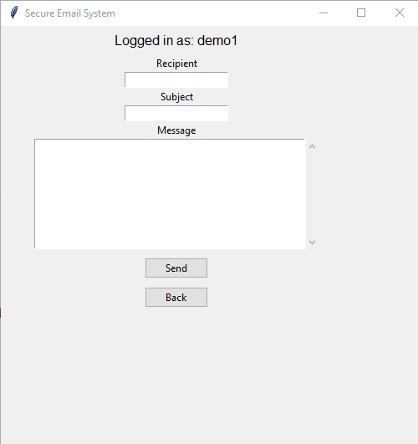
Fill in the required information and select send.
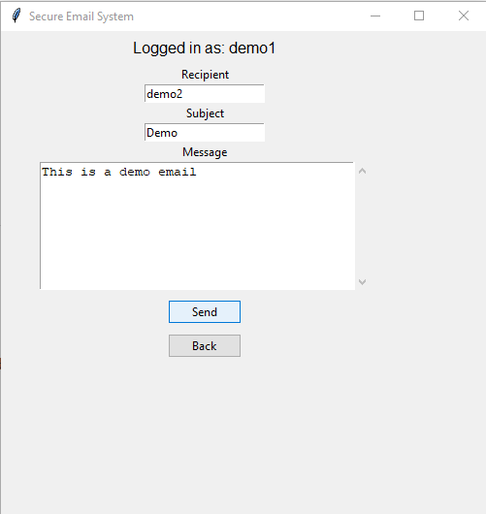
(demo2 was created in this session for the purpose of showing use case)
A pop up will show success
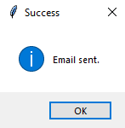

Viewing Inbox:
Login with the credentials of recipient’s user and password. On the dashboard, you will select ‘Inbox’
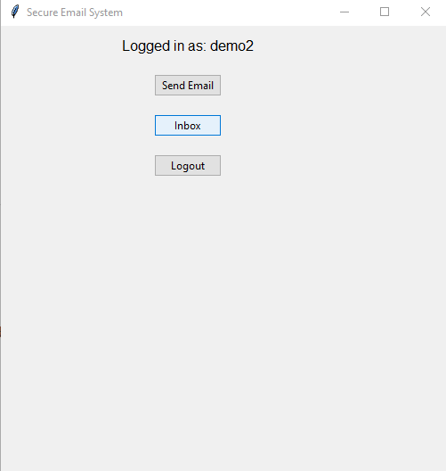
The inbox will show the received message
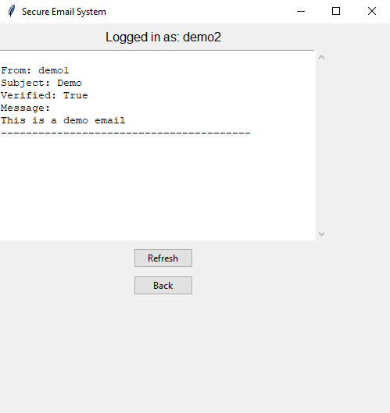
If the verification process was successful the Verification tag shows as true.

Logging out:
To log out, simply click ‘Back’ and then ‘Logout’
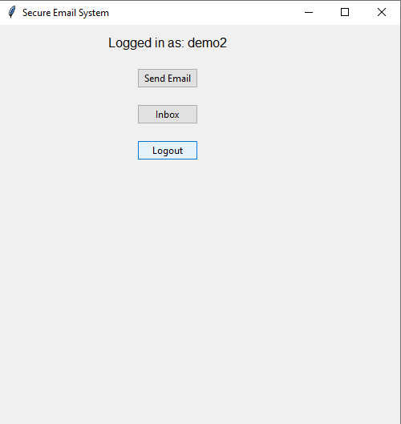

Teamwork Distribution
We worked collaboratively to bring the secure email system together. Each of us worked on a separate component and the responsibilities were evenly divided which covered all the main aspects.

Awwab Khalil: Client Application and Graphical User Interface
- The Tkinter GUI used by end-users
- The client logic for sending and receiving emails
- Integration flow from crypto to client side, and from cryptographic operations to the GUI buttons
- Handling registration, login, message sending and inbox retrieval

Marium Ahmad: Server Development
- Implemented Flask Server which included APIs
- Retrieval of public keys
- Secure message handling and uploads
- Local storage for user information and message packets
- Input validation and HTTP responses

Suhail Omar: Cryptography Implementation
- AES encryption and decryption (CTR mode)
- SHA-256 hashing
- RSA key generation, encryption and decryption
- Digital signatures and verification logic (also implemented on client side)
- Combining RSA and AES for hybrid encryption.

Hamra Malik: Documentation, Testing and Presentation
- Writing the multi-phase project report
- Create diagrams for explanation
- Preparing presentation slides
- Demonstrating code functionality
- Building user manual

Conclusion
This project effectively showed how to use client-server architecture and cryptography techniques to build and implement a fully functional secure email system. We gradually developed a system that guarantees user communication's confidentiality, authenticity, and integrity over the course of the seven phases.
We used SHA-256 for hashing and integrity checks, RSA for key exchange and digital signatures, and AES-256 for quick and safe message encryption. These elements were included into an organized process that encrypts, signs, transmits, decrypts, and verifies communications from beginning to end. While the client application manages all local cryptographic activities to guarantee that sensitive data never leaves the user's computer, the Flask-based server manages user registration, public key storage, and inbox management.
The creation of an intuitive graphical user interface (GUI) that allowed users to register, log in, send emails, and see inbox messages without using the command line was a significant contribution to the project. This interface enhanced overall usability and made the system accessible to non-technical users.
We verified through extensive testing that the system operates as anticipated: verification guarantees trust between communication parties, signatures prevent manipulation, and messages stay confidential. The finished program was well-organized since each team member contributed to a distinct core component, including the client, server, cryptography, and documentation.
In summary, the project not only satisfies the needs of a secure communication system but also shows how system architecture, programming, and cryptography can be integrated to produce a workable, real-world security solution.

References

NeuralNine. “RSA Encryption from Scratch - Math & Python Code.” Www.youtube.com, 8 May 2023, www.youtube.com/watch?v=D_PfV_IcUdA.
Lofaro, L. (2024, July 3). Working With JSON Data in Python – Real Python. Realpython.com. https://realpython.com/python-json/
Python Software Foundation. (2019). tkinter — Python interface to Tcl/Tk — Python 3.7.2 documentation. Python.org. https://docs.python.org/3/library/tkinter.html
Python Software Foundation. (2025, November 24). base64 — Base16, Base32, Base64, Base85 Data Encodings — Python 3.9.5 documentation. Docs.python.org. https://docs.python.org/3/library/base64.html
Stratis, K. (2018, June 4). Python Application Layouts: A Reference. Realpython.com; Real Python. https://realpython.com/python-application-layouts/#storing-state

